

R5 Enterprise Solutions

11.14.17

**Introduction**

RAVEN5’s contest marketing platform allows major brands and large organizations to implement and run both contests and sweepstakes.

The enterprise level program has been specifically developed for those organizations that would like the convenience of having a “custom” solution without the costs of development. The platform can be housed either in the cloud, or use client specific hosting. Utilizing our hosting will allow for fail safe backups, as well as performance load balancing.

**Features**

* Unlimited number of users
* Unlimited number of programs
* Unlimited number of leads (opt-ins)
* Unlimited duration of programs
* Unlimited use of rules template
* Unlimited use of privacy policy
* Social sharing for Facebook, Twitter, LinkedIn, Pinterest, Google+ & email
* Cloud based software solution
* No HTML coding required
* Customized microsite templates (up to 5)
* Customized email templates (up to 5)
* No limit on web fonts
* Access to landing templates
* Access to survey templates
* Access to sharing templates
* Publishing within an iframe available (SSL certificate required for Facebook embed)
* Access and customization of leader board
* Mobile friendly (all templates are responsive)
* Real time reporting
* Database downloads in .csv spreadsheets
* Channels available (different creative/copy) for multi-language or region support
* URL included, setup of subdomains and/or forwarding
* Access to contest design team at Raven5 for creation of program

**Standard Process**

1. Entrant is driven by email or direct link to microsite
2. Opt-in captures “name, email, gender, zip/postal” & rules/marketing agreement
3. Co­­upon selection
4. Survey (multiple/single choice)
5. Sharing to Facebook, LinkedIn, Twitter, Google+, Pinterest and Email
6. Thanks, includes exit links, print coupons and triggers auto-responder email

**Standard%20Opt-In.pdf**

**Reporting Samples**

Dashboard

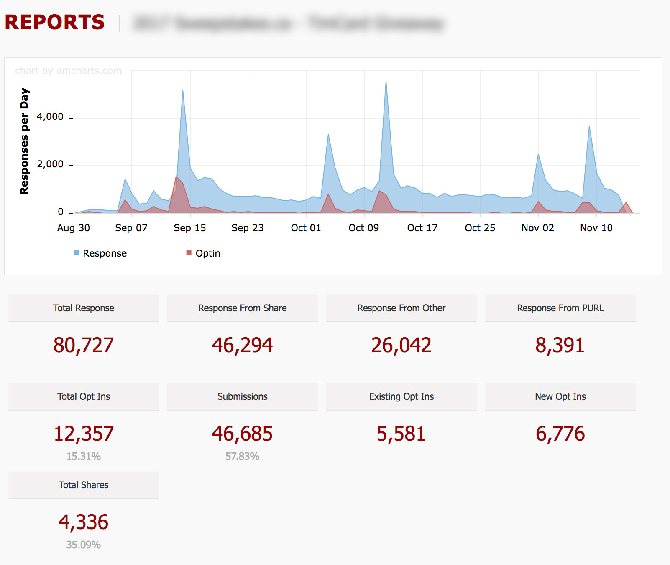

Traffic Analysis

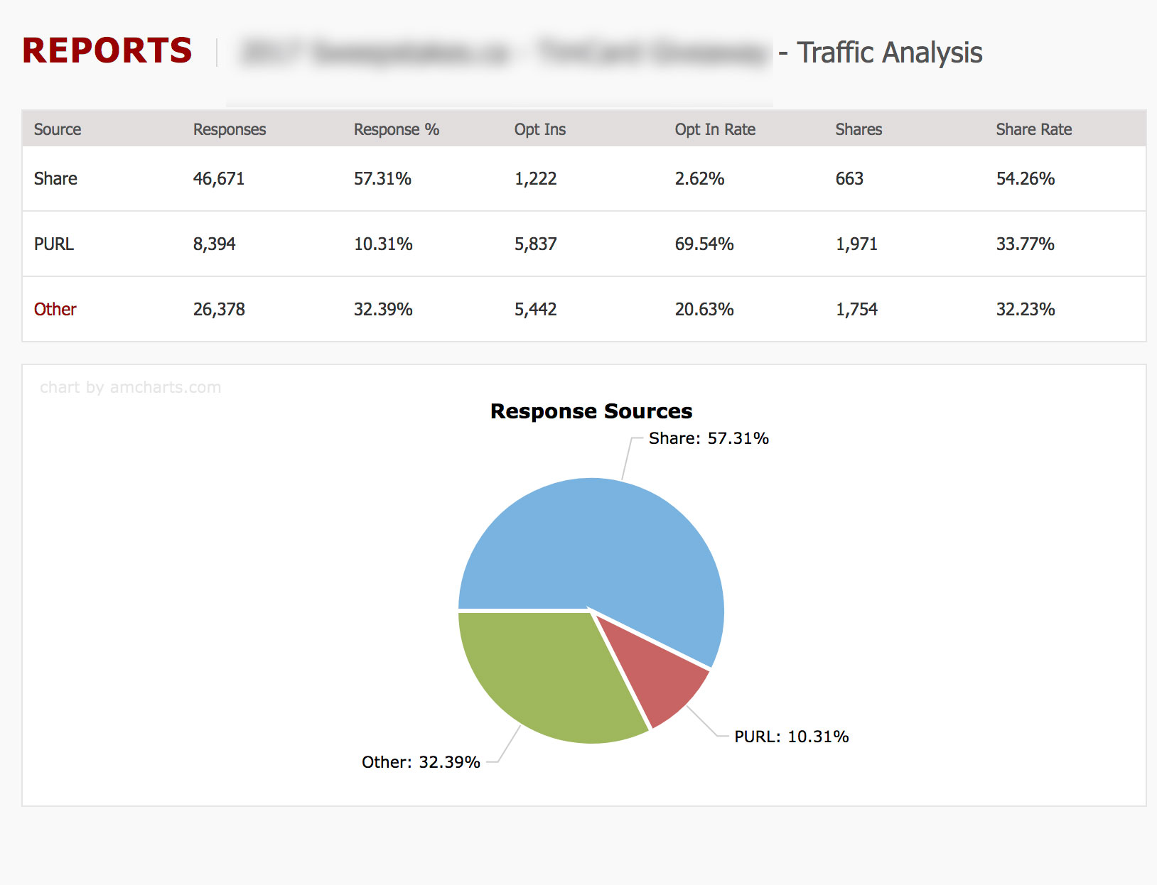

Survey

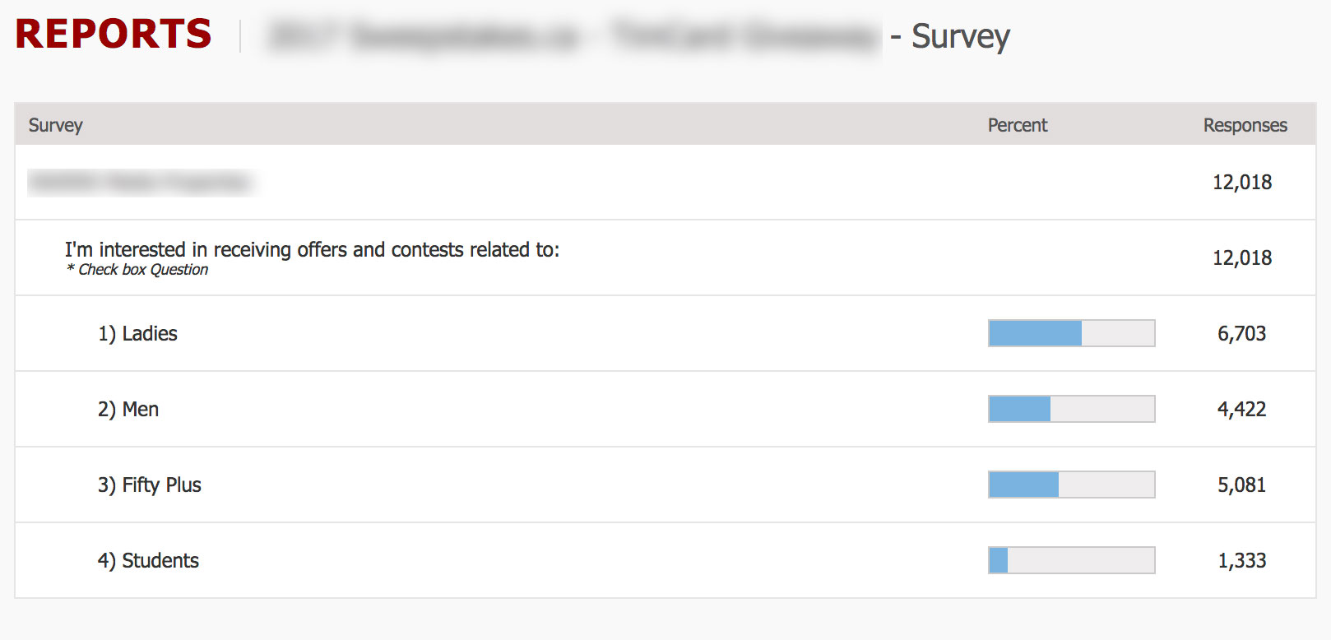

Leaderboard

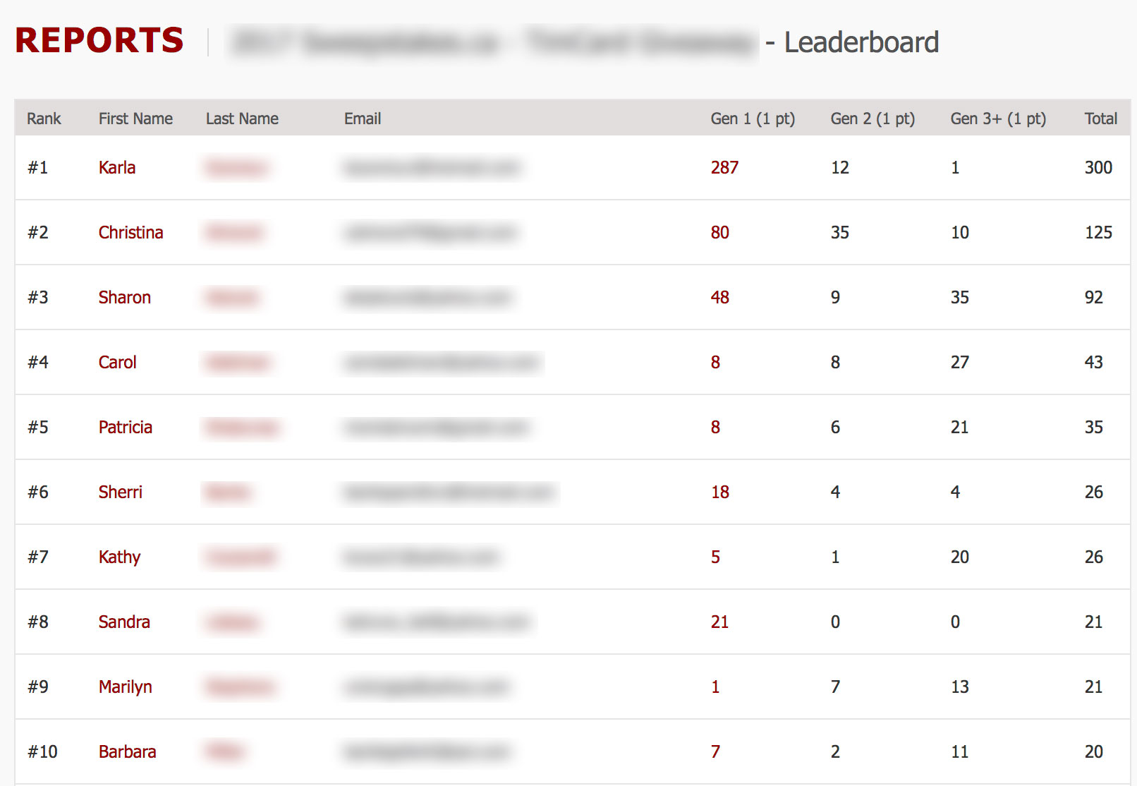

Generations

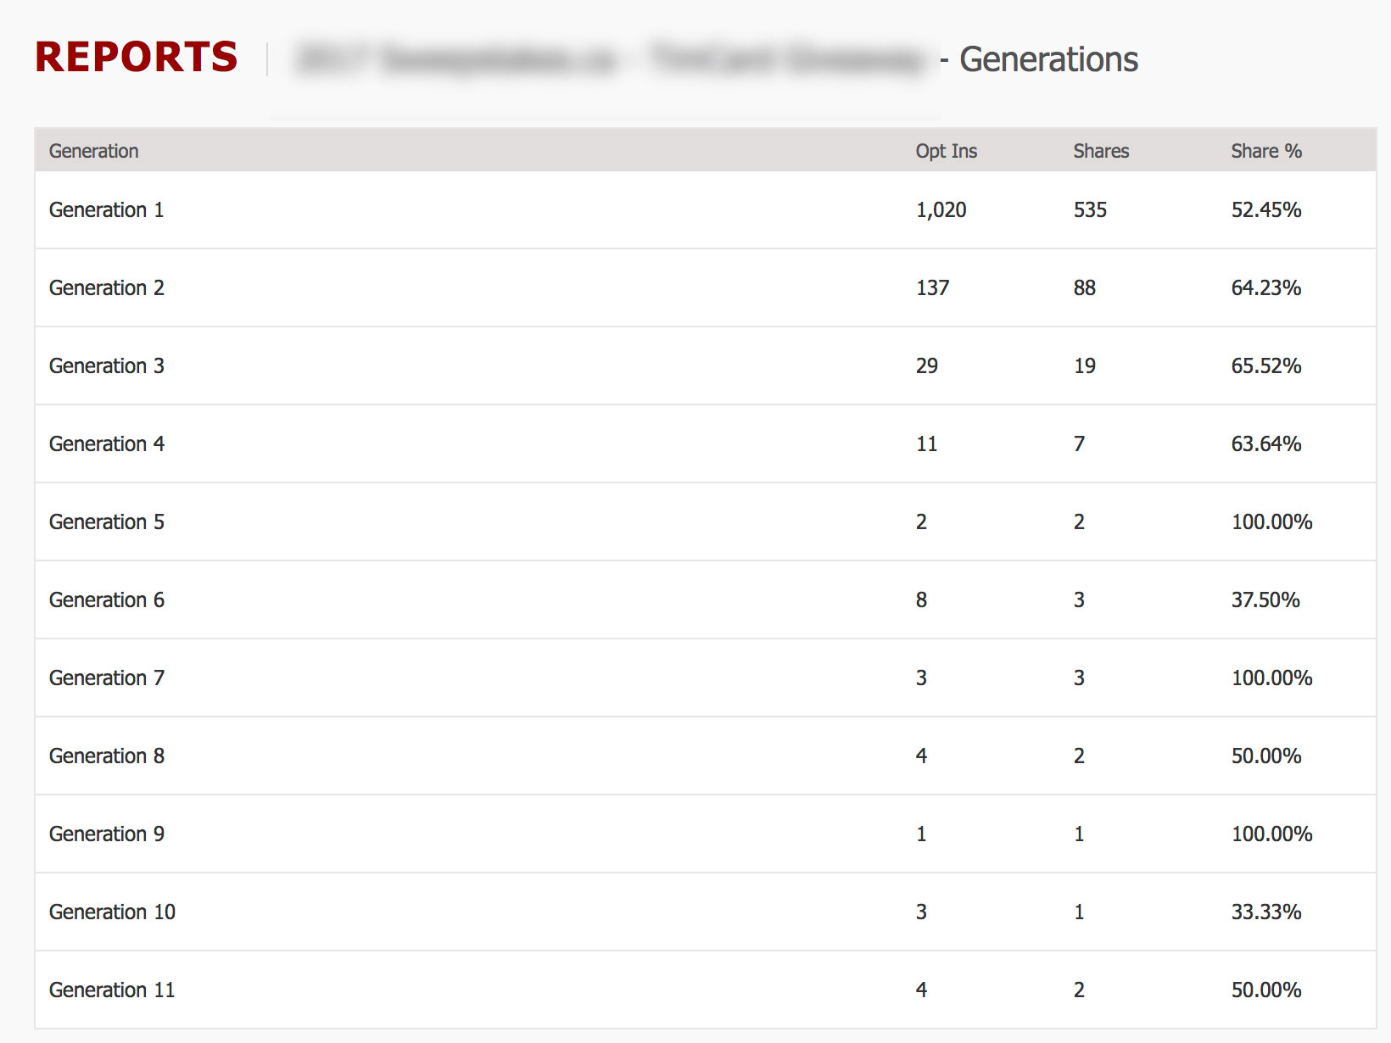

Sharing

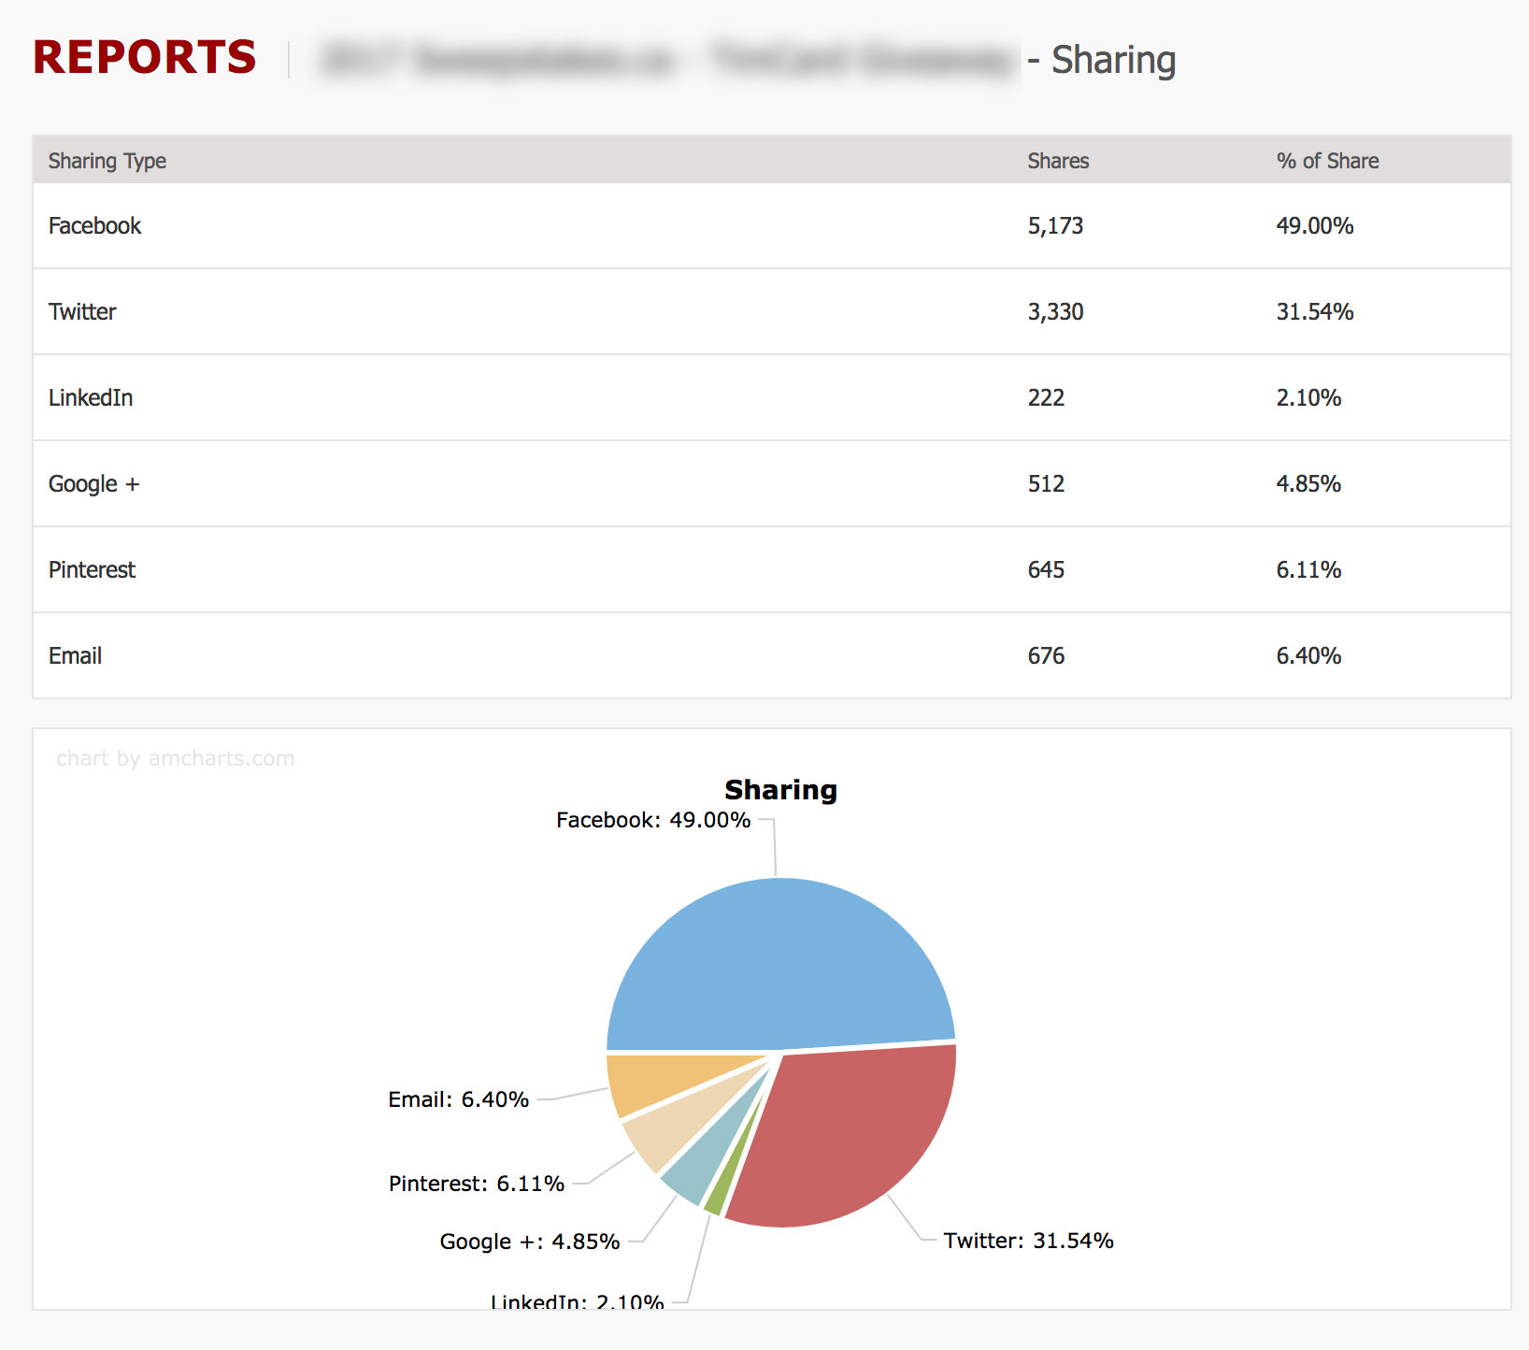

**Example of Costs (annual)**

Enterprise based program cloud based solution $45,000

Server based program installation and liaison $60,000 (optional)

Cost per contest program $100 each

Customized microsite templates design & develop $1,500 each

Customized email templates design & develop $400 each

Raven5 Concept/creative $95 hrly

Raven5 Custom development $130 hrly

Raven5 can arrange and provide staff “on call” for those business units or sub units that need assistance with implementing a program. The Raven5 can be leveraged on a as needed basis for implementation, creative, winner selection, notification and releases.

The platform can be modified and customized to meet various or required functions as part of the platform at an additional cost. We’d recommend an online meeting with our technology partner should time allow.

Additional information and further discussion, contact:

Michael Bickerton

Principal, RAVEN5 Ltd

[mbickerton@raven5.com](mailto:mbickerton@raven5.com)

m – 289 474 5505 x700